**Iteration 2**

SOS Consultants

Doctor Robert M. Barker

CIS 320-01

2 October 2017

**SOS Consultants**

**Vision (Small Project)**

**Version 1.1**

**Revision History**

|  |  |  |  |
| --- | --- | --- | --- |
| **Date** | **Version** | **Description** | **Author** |
| 09/20/2017 | 1.0 |  | Eric Chen |
| 9/30/2017 | 1.1 |  | Brad Riggs/Patrick Warren |
|  |  |  |  |
|  |  |  |  |

**Table of Contents**

1. Introduction 4

1.1 References 4

2. Positioning 4

2.1 Problem Statement 4

2.2 Product Position Statement 4

3. Stakeholder and User Descriptions 5

3.1 Stakeholder Summary 5

3.2 User Summary 5

3.3 User Environment 5

3.4 Summary of Key Stakeholder or User Needs 6

3.5 Alternatives and Competition 6

4. Product Overview 6

4.1 Product Perspective 7

4.2 Assumptions and Dependencies 7

5. Product Features 7

5.1 Volunteer Form Connects to Database 7

5.2 Donor Form and Comment Section 7

5.3 Patient Referral 7

5.4 Translate Webpage 7

5.5 Links to Social Media 7

6. Other Product Requirements

7. Appendix A 8

7.1 Problem Statement 8

7.2 Expected Solution 8

7.3 Business Case 8

7.4 Technical Feasibility 9

7.5 Economic Feasibility 10

7.6 Organizational Feasibility 11

7.7 Cost Benefit Analysis



**Vision (Small Project)**

1. **Introduction**

The purpose of this document is to collect, analyze, and define high-level needs and features of the SOS Louisville Database System. It focuses on the capabilities needed by the stakeholders and the target users, and why these needs exist. The details of how the SOS Louisville fulfills these needs are detailed in the use-case and supplementary specifications.

**1.1 References**

SOS Consultants PowerPoint

1. **Positioning**

**2.1 Problem Statement**

SOS Louisville manual records down donors and volunteers, which is very time consuming.

|  |  |
| --- | --- |
| The problem of | Not having a database |
| affects | SOS Louisville staffs |
| the impact of which is | Time consuming |
| a successful solution would be | A simple database to record all the information instead of manually recording it. |

**2.2 Product Position Statement**

By using this database, we assume, SOS Louisville will have enough time for other tasks.

|  |  |
| --- | --- |
| For | SOS Louisville |
| Who | The person usually records the data |
| The Database System | Is a software application |
| That | Provides the ability to automate the process of recording and storing donors and volunteers |
| Unlike | Currently, everything is still being manually entered |
| Our product | Provides SOS Louisville staffs with easy and simple to use database that will speed their process |

1. **Stakeholder and User Descriptions**

**3.1 Stakeholder Summary**

|  |  |  |
| --- | --- | --- |
| **Name** | **Description** | **Responsibilities** |
| Board of Directors | Board of Directors. | Responsible for approving events, monitor progress, and approve funding. |
| Administrators | Manage/update website, facilitate volunteers, gather patient data and schedule events. | Responsible for the upkeep of the entire website, database, and business. |

**3.2 User Summary**

|  |  |  |  |
| --- | --- | --- | --- |
| **Name** | **Description** | **Responsibilities** | **Stakeholder** |
| Volunteer | Individuals who volunteer to help during events and clinics. Fill out forms online. | Responsible for filling out the volunteer form and submitting for approval to help at events and clinics. | Administrators |
| Donor | Provide monetary donations. | Responsible for donating online. | Self |
| Doctor/Doctor’s Office | Refer patients to SOS Louisville. | Responsible for referring patients in need of care that fall under the correct circumstances to SOS Louisville. | Administrators |
| Administrator | Administrators. | Provide up-to-date information on events, types of work they perform, and program statistics. | Self |

**3.3 User Environment**

The database system will be used by the staff at SOS Louisville. As of right now, according to SOS Louisville’s website there are five staff members. Any donor, volunteer, and patient information has to be manually entered into a spreadsheet from an email. Currently donor information is stored on Google Suite and volunteer and patient information is stored locally.  Improved forms will be used to automatically store donor, volunteer, and patient information to a database stored on a cloud server removing the risk of hardware failure. With a functional relational database, they will be able to run simple queries to pull specific information needed for the planning, scheduling, and coordination of organizational events.

**3.4 Summary of Key Stakeholder or User Needs**

|  |  |  |  |  |
| --- | --- | --- | --- | --- |
| **Need** | **Priority** | **Concerns** | **Current Solution** | **Proposed Solutions** |
| Volunteer Submission | Primary | No online form that connects to a database | Email all contents to SOS Louisville Staff | Create a form that connects to a relational database to automatically record all data |
| Donor Submission | Primary | No way for donors to be recognized if they preferred | Routes to a Paypal payment system and gets saved in a CSV file | Add a section that allows donors to enter in their personal information. Leave blank for anonymity |
| Patient Referral | Primary | All information gets sent as a file and manually recorded | Doctors login with a password and send information to SOS Louisville | Doctors will still log in, but there will be a form with all possible information relating to a patient |
| Translate Webpage | Secondary | 76% of patients are Spanish speakers and cannot convert the webpage | No conversion at this time | Add in a language conversion tool that will change the language of the webpage |
| Social Media Links | Secondary | Links are broken | Currently have social media icons available, but not all are functional | All links will be functional and point to popular social media websites |

**3.5 Alternatives and Competition**

Instead of the proposed solution, the alternative would be to stay with the current solution, which would cause SOS Louisville to lose money.

1. **Product Overview**

**4.1 Product Perspective**

**4.1.1 Employee Management**

1. Volunteers
   1. Volunteer Form
      1. Volunteer Table
2. Staff
   1. Flows Directly To Staff Table

**4.1.2 Funding**

1. Donors
   1. Donor Form
      1. Donor Table
2. Grants
   1. Written to Grant Organization for Funding
      1. Grant Table

**4.1.3 Event Management**

1. Patients
   1. Patient Referral Form
      1. Patient Table
2. Facilities
   1. Flows Directly to Facility Table

**4.1.4 Data Management**

1. All tables are put into Relational Database
2. Events Created

**4.2 Assumptions and Dependencies**

1. Assumed website will stay as WordPress
2. Database will be created for their business processes
3. Cloud computing for storing the database is recommended
4. Forms will directly access database
5. **Product Features**

**5.1 Volunteer Form Connects to Database**

Volunteer forms need to be able to connect to a database

**5.2 Donor Form and Comment Section**

The donor form should have a section that allows for donor comments

**5.3 Patient Referral**

Patient referrals should be a form filled out by the doctor or doctor’s office. It will transfer to a database

**5.4 Translate Website**

Site should have a way to translate the website to Spanish

**5.5 Links to Social Media**

Should have valid social media links on their site

1. **Other Product Requirements**

Recommended that when the system is set up the administrators back up all of their information to a secondary device. This will lessen the likelihood that information will be lost.

1. **Appendix A**

**7.1 Problem Statement**

Surgery on Sunday Louisville is a non-profit organization that provides outpatient surgical and endoscopic procedures to people in need. They are going to need an efficient website that will include best practices and improved business processes that will ultimately lead to significant growth of the organization.

After analyzing SOS Louisville’s business processes, we have found many areas that can be greatly improved to have a substantial impact that will lead to growth of the organization. One of the problems we noticed was their lack of a functional social media link. The link was hard to find and did not work correctly. Another issue we have come across was the inability to translate the webpage from English to Spanish. This is a problem considering 76% of their patients are Spanish speaking. A third area for improvement we have noticed is the lack of functional donor forms. All information from donors currently comes directly from PayPal. Donors are unable to leave any type of message along with the donation. One of the bigger issues is the fact that all of their donor information, volunteer information, facility information, staff information is not currently being stored in one central location to where it can interact.

**7.2 Expected Solution**

After taking a look at a handful of issues and areas that can be improved, here is how we propose to fix it. First, you will want to include links to social media on every page of the website. Whether it is at the bottom or top of each page, it needs to be easily accessed to direct users to your social media pages to get more likes and shares leading to greater awareness. This will bring in more volunteers and donations. Second, a drop-down menu will be added to the top of the webpage that will allow users to toggle between English and Spanish. Since the vast majority of your patients are Spanish speaking, this will allow their family members to better understand your organization making them more likely to support your cause by donating. Third, donor forms need to be improved, when a donor fills out a form to donate, their information needs to be sent straight to you and stored into a database to avoid any potential oversights, avoid potential errors that comes with manual entry, and to eliminate time waste from manual entry. The same thing goes for volunteers and patients, forms need to automatically add their information into a database. The fourth and biggest improvement that will tie everything together is creating a relational database for all volunteers, patients, facilities, staff, events, and etc. This will put all of the information into one central location and simple queries can be ran to pull any piece of information that you need making organizing and scheduling events more streamlined saving lots of valuable time.

**7.3 Business Case**

Let’s assume that SOS Louisville’s average donation is currently $50.00 with approximately 150 donors per year totaling to $7500.00 in donations. Also, assume that an average grant is $5000.00 at 5 grants per year for a total of $25000.

The following describes the estimated increase in donations from making social media accessible from every page on the website:

Pessimistic outcome – 5% increase totaling to an additional $375.00 per year.

Expected outcome – 10% increase totaling to an additional $750.00 per year.

Optimistic outcome – 15% increase totaling to an additional $1125.00 per year.

Allowing the website to be translated to Spanish will increase the likeliness of the friends and family members of the Spanish speaking patients to donate. Assuming that surgeries are performed on 50 Spanish speaking patients per year and each patient has 10 friends and family members totaling to 500 you can expect the following:

Pessimistic outcome – 1% more of friends and family members donate at the average rate totaling to $250.00 more per year.

Expected outcome – 2% more of friends and family members donate at the average rate totaling to $500.00 more per year.

Optimistic outcome – 3% more of friends and family members donate at the average rate totaling to $750.00 more per year.

Improving the donation process making it more user friendly and giving the donors the chance to leave feedback or donate on a recurring basis can result in the following increase:

Pessimistic outcome – 5% increase in donations totaling to an additional $375.00 per year

Expected outcome – 10% increase in donations totaling to an additional $750.00 per year.

Optimistic outcome – 15% increase in donations totaling to an additional $1125.00 per year.

Creating a relational database that will automatically store donor and volunteer information can save time and allow for more grant writing and communication with donors and volunteers which can result in the following increase:

Pessimistic outcome – 1 more grant received per year with a 5% increase in donations totaling to an additional $5375.00 per year

Expected outcome – 2 more grants received per year with a 10% increase in donations totaling to an additional $10750.00 per year.

Optimistic outcome – 3 more grants received per year with a 15% increase in donations totaling to an additional $16125.00 per year.

**7.4 Technical Feasibility**

|  |  |
| --- | --- |
| Familiarity with Functional area | SOS Consultants have a solid understanding of the current system SOS Louisville is currently working with and will be able to implement a system with minimal risk to perform the same tasks in a more efficient manner. |
| Familiarity with Technology | The technology used should pose minimal risk within the organization and will be easy to use. Learning basic functions of the new database will be the main risk involved. |
| Project Size | With this being a smaller project that is estimate to take 3-5 months and no major system requirements, the risk should be minimal. |
| Compatibility | There should be no compatibility issues. The data created will be built from scratch and will only require data entry from existing spreadsheets to populate database with existing information. |

**7.5 Economic Feasibility**

|  |  |
| --- | --- |
| **Development Costs** | |
| DBMS License | $0 |
| Cloud Server | $26 |
| **Annual Operating Costs** | |
| CMS Fee | $0 |
| PS Fee | $0 |
| Cloud Server | $102 |
| **Annual Benefits** | |
| Social media easier to find on website | 750.00 (10% increase in donations) |
| Language Translator | 500.00 (2% increase in donations from patient friends and family members) |
| Relational Database | 10750.00 (10% increase in donations + 2 additional grants) |
| Improved Donation Process | $750 (10% increase in donations) |
| **Intangible Benefits and Costs** | |
| Increase in volunteers |  |
| Greater organizational awareness |  |

**7.6 Organizational Feasibility**

**Project Champion:** Erica Sutton and Barbara Martin

**Senior Management:** Erica Sutton and Barbara Martin

**Users:** SOS Louisville Staff

**Other Stakeholders:** Donors, Volunteers, Facilities, and Patients

The project is strategically aligned with the business because with the improvements to their business processes it will allow them to operate more efficiently and establish a solid foundation that will allow them to keep up with their goal of organizational growth. This means that if they were to double or triple in size, the amount of overhead from the improved processes will be minimal as opposed to their current processes.

**7.7 Cost Benefit Analysis**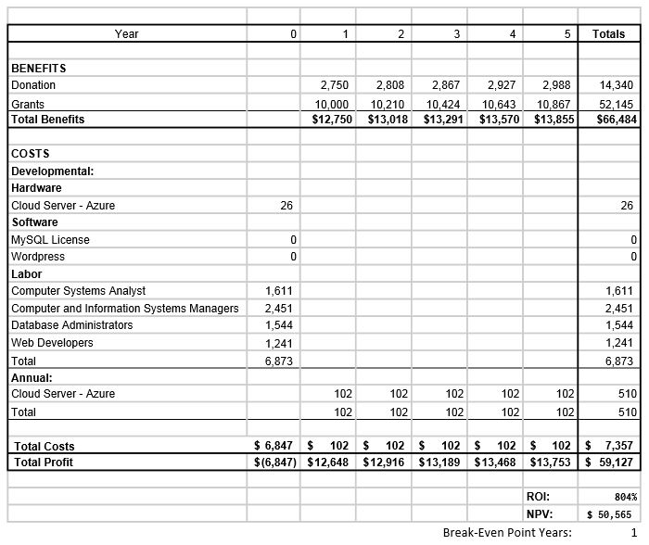

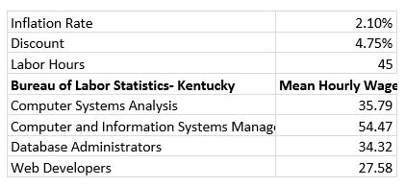

Date: 2 October 2017

To: Surgery on Sunday (SOS) Louisville

From: SOS Consultants

Subject: System Request

This memo will provide the business reasons for building a new system and the value that the system is expected to provide. First, recognition needs to be given to Dr. Robert M. Barker and the University of Louisville College of Business, they are providing undergraduate students with an amazing opportunity to work together with a local non-profit organization to improve their current system. Next, the business-related reasons for initiating the new system will be stated. Followed by the business capabilities that the system will provide and the benefits that the system will provide for the organization. And finally, any issues that are relevant to the implementation of the system.

**Business Need**

* Decrease overhead of managing donor and volunteer information
* Increase donations.
* Improve marketing
* Increase demographic communications.
* Increase flow of information

**Business Requirements**

* The current system lacks a way to keep the community involved i.e. new letters
* The current system lacks links to social media on website
* The current system lacks a database to store donor and volunteer information.
* The current system lacks automated storage of donor and volunteer information to database
* The current system lacks a way to translate the webpage
* The current system lacks compatible donor forms
* The current system lacks several donation options

**Business Value**

* Social media links easier to find on website - 10% increase in donations totaling to additional $750.00 per year.
* Language translator - 2% increase in friends/family of patients donate totaling to additional $500.00 per year.
* Saved time and effectiveness from relational database tied to donor and volunteer forms. 2 additional grants at $5,000 each + 10% increase in donations per year. $10,750.00

**Special Issues or Constraints**

* Needs to be an easy-to-use system
* Limited budget
* Prefer to implement while still using WordPress if possible
* Planning must be done by Dec. 4th (end of the fall semester)

**List of Use-Cases**

1. Physician Volunteer
   1. Register for an event

Volunteers will fill out a form

1.1.1 Add the volunteer

1.1.2 Modify the volunteer

1.1.3 Delete the volunteer

1.2 Store into database

Take the completed form and store it into the database

     1.2.1 Store the form

     1.2.1 Modify the form

     1.2.3 Delete the form

1. Non-Physician Volunteer

2.1 Register for an event

Volunteers will fill out a form

2.1.1 Add the volunteer

2.1.2 Modify the volunteer

2.1.3 Delete the volunteer

2.2 Store into database

Take the completed form and store it into the database

     2.2.1 Store the form

     2.2.1 Modify the form

     2.2.3 Delete the form

1. General Volunteer

3.1 Register for an event

Volunteers will fill out a form

3.1.1 Add the volunteer

3.1.2 Modify the volunteer

3.1.3 Delete the volunteer

3.2 Store into database

Take the completed form and store it into the database

     3.2.1 Store the form

     3.2.1 Modify the form

     3.2.3 Delete the form

1. Donor

4.1 Register to donate

A form for donors to fill out

           4.1.1 Add the donor

           4.1.2 Modify the donor

           4.1.3 Delete the donor

4.2 Make donation

Donations will be made using PayPal

4.2.1 One time payment

4.2.2 Recurring payment

4.3 Leave comments

      A comment section for donors

4.3.1 Add the comment

4.3.2 Modify the comment

4.3.3 Delete the comment

4.4 Store into database

Take the information and store it into the database

     4.4.1 Store the form

     4.4.1 Modify the form

     4.4.3 Delete the form

1. Patient

5.1 Sign in

Old patients sign in, new patients sign up

5.1.1 Create new patient

5.1.2 Modify patient

5.1.3 Delete patient

5.2 Store into database

Take the information and store it into the database

     4.4.1 Store the patient

     4.4.1 Modify the patient

     4.4.3 Delete the patient

1. Staff

6.1 Create an event

Create an event for the volunteers

6.1.1 Add the event

6.1.2 Modify the event

6.1.3 Delete the event

6.2 Check event registration

Staff will check to see event information

6.3 Translate website

Translate the website to Spanish

6.4 Access to link

Provide a better social media link

6.5 Check information

Generate a report listing from the stored information

1. Doctor

7.1 Check event

Check events that involves patients

7.2 Fill out form

Patient referrals form filled out by the doctor

7.2.1 Add the form

7.2.2 Modify the form

7.2.3 Delete the form

7.3 Store into database

Take the information and store it into the database

     7.3.1 Store the patient

     7.3.2 Modify the patient

7.3.3 Delete the patient

8. Events

8.1 Create events

Events get created directly from the database

8.1.1 Add Volunteer(s)

8.1.2 Add Patient(s)

8.1.3 Add Location

8.1.4 Modify Volunteer(s)

8.1.5 Modify Patient(s)

8.1.6 Modify Location

8.1.7 Delete Volunteer(s)

8.1.8 Delete Patient(s)

8.1.9 Delete Location

8.2 Track Fundraising

Store fundraising information from the event

8.2.1 Add donor

8.2.2 Modify donor

8.2.3 Delete donor

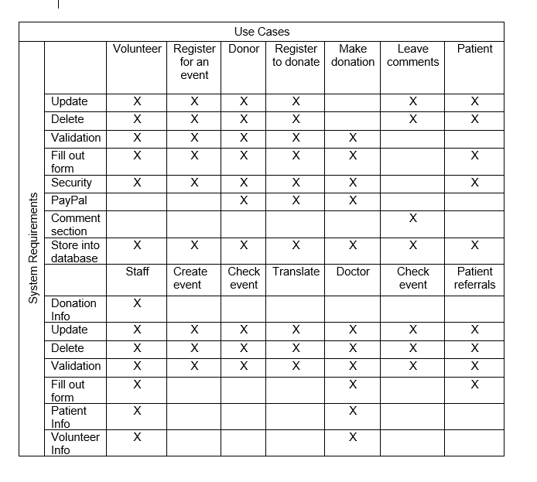

**Initial Architecture Considerations**

**Design Viewpoint**

Below, we see how the organization’s website looks from a design viewpoint. Essentially, users access the website, they can make payments and fill out forms which get stored in the cloud, and the admin team runs all facets of the website.

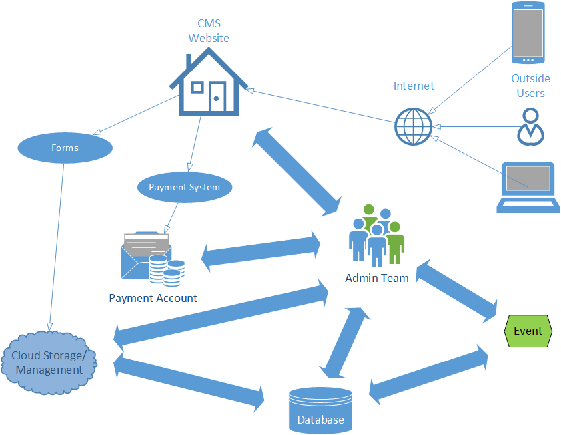

**Realization Viewpoint**

Now that we have a design viewpoint of the architecture, we can get a visual of the realization viewpoint. With this in place, we can begin to build on the architecture already in place to streamline processes and cut down on unnecessary tasks. Volunteers, donors, patients, and visitors can login through the internet and access [www.soslouisville.or](http://www.soslouisville.or)g. From there, they can fill volunteer forms, donor forms, and donate money to the organization’s cause. Admins have free reign of the website, the PayPal account, the GSuite account, MySQL, and are in charge of creating events.

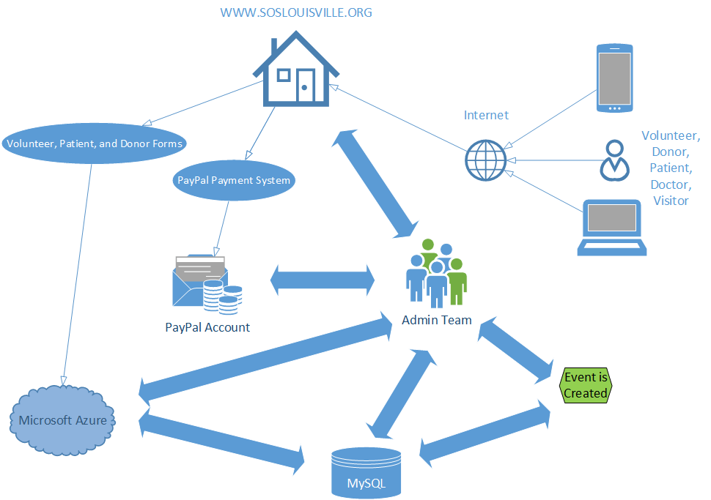

**Risk Analysis**

The criteria that assigns high or low risk value to each case is showing how important they are for Surgery on Sunday Louisville. The risk shows what cases could bring the most revenue to Surgery on Sunday Louisville and what project would help them obtain a better position to be able to accomplish to have more information for donation that Surgery on Sunday Louisville needs.

**High Risk Cases**

* Event
* Donations
* Patient
* Grants

**Low Risk Cases**

* Volunteer
* Staff
* Donor
* Comment

Along with the risk items from the use cases, there are other areas that can be considered high and low risk for your organization. From here, we can determine which risks to take on based on the value that it will add.

**High Risk**

* Donation System
* Microsoft Azure with MySQL Database
* WordPress in Azure

**Low Risk**

* Functional Event Calendar
* Functional Social Media Links

Surgery on Sunday will have to take some risk when determining how to use and manage their new system. High risk comes with the change of any system, but if we can mitigate as much as possible then it will be an easy transition. Moreover, the low risk cases and low risk in general will not be difficult to include and will greatly improve their processes.

**Gantt Chart**

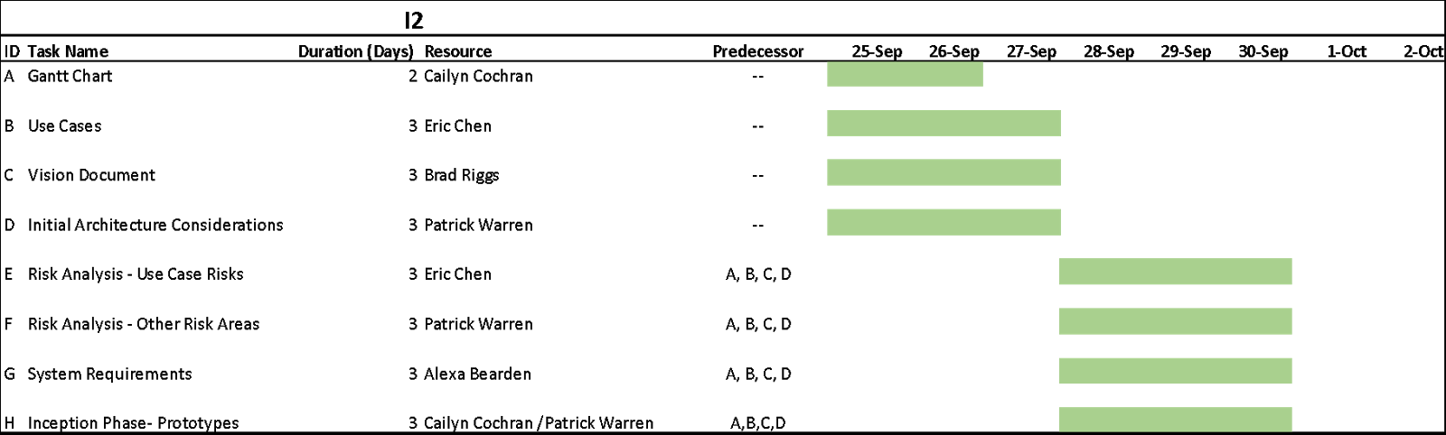

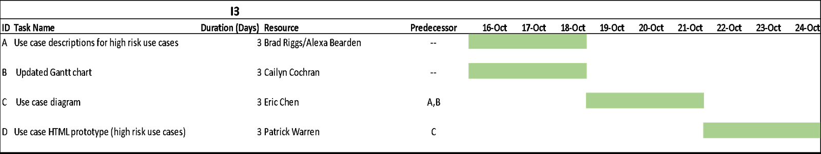

**Inception Phase Prototype**

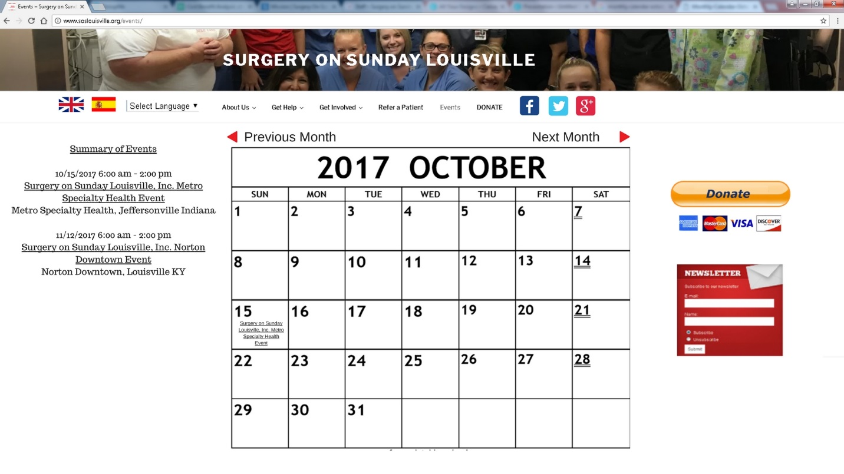

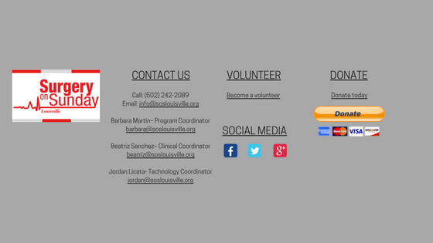

**“To-Be” Model**

As stated in the solution, we propose to create a relational database to streamline the process for storing volunteers, donors, patients, facilities, and staff, manage this content easily, and create events based off the information and needs of the patients. We will create forms to allow users to input all the information so it gets stored automatically from the website to the database. From here, SOS Louisville can run queries to pull all information related to a certain event. For example, if they would like to pull all patients in need of colonoscopies and all volunteers who can and/or have performed colonoscopies, it would be easy to do so.

